LAPORAN PRAKTIKUM PEMROGRAMAN WEB MODUL 10: Javascript Lanjutan



Disusun Oleh:
Nama: Andhika Yuridho
NIM: 707012500059
Kelas: D4SIKC-49-04

UNIVERSITAS TELKOM
FAKULTAS ILMU TERAPAN
JURUSAN S1 TERAPAN SISTEM INFORMASI KOTA CERDAS
TAHUN AJARAN 2026

- Tujuan Praktikum
Setelah mengikuti praktikum ini mahasiswa diharapkan dapat:
- Memahami konsep dasar JavaScript sebagai bahasa pemrograman web.
- Memahami fitur Modern JavaScript (ES6+) dan perannya sebagai fondasi React.
- Mampu menggunakan sintaks ES6+ secara tepat dan konsisten.
- Memahami konsep state, immutability, dan functional programming.
- Mampu membangun aplikasi sederhana berbasis state menggunakan Vanilla JavaScript.

- Alat dan Bahan
Untuk menjalankan modul ini, diperlukan komputer atau laptop dengan sistem operasi Windows, Linux, atau macOS, minimal prosesor 1 GHz, RAM 2GB (disarankan 4GB atau lebih), serta browser modern seperti Google Chrome, Mozilla Firefox, atau Microsoft Edge.
Perangkat lunak yang digunakan meliputi:
- Code editor (Visual Studio Code, Sublime Text, atau sejenisnya)
- Web browser
Bahan yang dibutuhkan:
- File HTML dasar
- File JavaScript (.js)

Langkah-Langkah Praktikum
- Membuat folder project webstore.
- Menyusun struktur folder:
- index.html, style.css, app.js
- src/api/productApi.js
- src/core/Store.js, src/core/utils.js
- src/components/ProductList.js, src/components/Cart.js, src/components/Newsletter.js
- Mengisi file HTML, CSS, dan JavaScript modular sesuai instruksi modul.
- Melakukan perbaikan teknis minimum agar aplikasi berjalan stabil:
- Konsistensi path import.
- Perbaikan typo dari materi PDF.
- Validasi target elemen DOM saat rendering.
- Menjalankan aplikasi menggunakan Live Server.
- Menguji fitur utama: render produk, tambah ke cart, checkout, dan newsletter.

- Hasil dan Dokumentasi Program
Berikut seluruh kode program webstore:
File: index.html
﻿<!doctype html>
<html lang="id">
<head>
<meta charset="UTF-8" />
<meta name="viewport" content="width=device-width, initial-scale=1.0" />
<title>Vanilla JS Web Store</title>
<link rel="preconnect" href="https://fonts.googleapis.com" />
<link rel="preconnect" href="https://fonts.gstatic.com" crossorigin />
<link
href="https://fonts.googleapis.com/css2?family=Inter:wght@400;500;600&family=Merriweather:ital,wght@0,400;0,700;1,400&display=swap"
rel="stylesheet"
/>
<link rel="stylesheet" href="style.css" />
<script src="https://code.jquery.com/jquery-3.7.1.min.js"></script>
<script type="module" src="app.js" defer></script>
</head>
<body>
<div id="app">
<div class="container">
<div class="listing-header">
<nav class="breadcrumb" aria-label="Breadcrumb">
<a href="#">
<svg xmlns="http://www.w3.org/2000/svg" fill="currentColor" viewBox="0 0 20 20">
<path d="m19.707 9.293-2-2-7-7a1 1 0 0 0-1.414 0l-7 7-2 2a1 1 0 0 0 1.414 1.414L2 10.414V18a2 2 0 0 0 2 2h3a1 1 0 0 0 1-1v-4a1 1 0 0 1 1-1h2a1 1 0 0 1 1 1v4a1 1 0 0 0 1 1h3a2 2 0 0 0 2-2v-7.586l.293.293a1 1 0 0 0 1.414-1.414Z" />
</svg>
Home
</a>
<svg style="color: #9ca3af" xmlns="http://www.w3.org/2000/svg" fill="none" viewBox="0 0 24 24">
<path stroke="currentColor" stroke-linecap="round" stroke-linejoin="round" stroke-width="2" d="m9 5 7 7-7 7" />
</svg>
<a href="#">Products</a>
<svg style="color: #9ca3af" xmlns="http://www.w3.org/2000/svg" fill="none" viewBox="0 0 24 24">
<path stroke="currentColor" stroke-linecap="round" stroke-linejoin="round" stroke-width="2" d="m9 5 7 7-7 7" />
</svg>
<span style="color: var(--text-muted)">Electronics</span>
</nav>
<div class="toolbar">
<h2 class="page-title">Electronics</h2>
<div class="toolbar-actions">
<button class="btn-secondary" type="button">
<svg xmlns="http://www.w3.org/2000/svg" fill="none" viewBox="0 0 24 24">
<path stroke="currentColor" stroke-linecap="round" stroke-width="2" d="M18.796 4H5.204a1 1 0 0 0-.753 1.659l5.302 6.058a1 1 0 0 1 .247.659v4.874a.5.5 0 0 0 .2.4l3 2.25a.5.5 0 0 0 .8-.4v-7.124a1 1 0 0 1 .247-.659l5.302-6.059c.566-.646.106-1.658-.753-1.658Z" />
</svg>
Filters
</button>
<button class="btn-secondary" type="button">
<svg xmlns="http://www.w3.org/2000/svg" fill="none" viewBox="0 0 24 24">
<path stroke="currentColor" stroke-linecap="round" stroke-linejoin="round" stroke-width="2" d="M7 4v16M7 4l3 3M7 4 4 7m9-3h6l-6 6h6m-6.5 10 3.5-7 3.5 7M14 18h4" />
</svg>
Sort
</button>
</div>
</div>
</div>
<div id="product-list" class="product-grid"></div>
<div id="cart" class="cart-section"></div>
</div>
</div>
</body>
</html>
File: style.css
﻿:root {
--primary: #0d9488;
--primary-hover: #0f766e;
--primary-light: #ccfbf1;
--bg-color: #f9fafb;
--card-bg: #ffffff;
--text-main: #111827;
--text-muted: #6b7280;
--border-color: #e5e7eb;
--rating-star: #facc15;
--font-serif: "Merriweather", serif;
--font-sans: "Inter", sans-serif;
--radius: 8px;
}
* {
box-sizing: border-box;
margin: 0;
padding: 0;
}
body {
font-family: var(--font-sans);
background: var(--bg-color);
color: var(--text-main);
line-height: 1.5;
-webkit-font-smoothing: antialiased;
}
.container {
max-width: 1280px;
margin: 0 auto;
padding: 32px 16px;
}
.flex-row,
.breadcrumb,
.breadcrumb a,
.toolbar,
.toolbar-actions,
.feature,
.rating-row,
.card-footer {
display: flex;
align-items: center;
}
.btn-primary,
.btn-secondary {
display: inline-flex;
align-items: center;
justify-content: center;
gap: 8px;
border-radius: var(--radius);
font-size: 0.875rem;
font-weight: 500;
cursor: pointer;
transition: 0.2s;
}
svg {
width: 16px;
height: 16px;
}
.listing-header {
margin-bottom: 32px;
}
.page-title {
font-family: var(--font-serif);
font-size: 1.875rem;
font-weight: 700;
}
.toolbar {
justify-content: space-between;
flex-wrap: wrap;
margin-top: 16px;
gap: 16px;
}
.toolbar-actions {
gap: 12px;
}
.breadcrumb {
gap: 8px;
font-size: 0.875rem;
color: var(--text-muted);
margin-bottom: 12px;
}
.breadcrumb a {
color: var(--text-muted);
text-decoration: none;
gap: 6px;
}
.breadcrumb a:hover {
color: var(--primary);
}
.btn-secondary {
background: white;
border: 1px solid var(--border-color);
color: var(--text-main);
padding: 8px 12px;
}
.btn-secondary:hover {
background: #f3f4f6;
color: var(--primary);
}
.btn-primary {
background: var(--primary);
color: white;
border: none;
padding: 10px 20px;
}
.btn-primary:hover {
background: var(--primary-hover);
}
.btn-primary svg {
width: 20px;
height: 20px;
}
.product-grid {
display: grid;
grid-template-columns: repeat(auto-fill, minmax(250px, 1fr));
gap: 24px;
margin-bottom: 32px;
}
.product-card {
background: var(--card-bg);
border: 1px solid var(--border-color);
border-radius: var(--radius);
overflow: hidden;
display: flex;
flex-direction: column;
transition: box-shadow 0.2s;
box-shadow: 0 1px 2px 0 rgba(0, 0, 0, 0.05);
}
.product-card:hover {
box-shadow: 0 4px 6px -1px rgba(0, 0, 0, 0.1);
}
.card-image {
height: 220px;
padding: 24px;
display: flex;
justify-content: center;
background: white;
}
.card-image img {
max-height: 100%;
max-width: 100%;
object-fit: contain;
}
.card-content {
padding: 24px;
display: flex;
flex-direction: column;
flex: 1;
}
.badge {
background: var(--primary-light);
color: var(--primary);
font-size: 0.75rem;
font-weight: 600;
padding: 2px 10px;
border-radius: 4px;
width: fit-content;
margin-bottom: 12px;
}
.card-title {
font-size: 1.125rem;
font-weight: 600;
color: var(--text-main);
text-decoration: none;
margin-bottom: 8px;
line-height: 1.4;
display: -webkit-box;
-webkit-line-clamp: 2;
line-clamp: 2;
-webkit-box-orient: vertical;
overflow: hidden;
}
.card-title:hover {
text-decoration: underline;
}
.rating-row {
gap: 8px;
margin-bottom: 16px;
}
.stars {
display: flex;
color: var(--rating-star);
}
.rating-score {
font-size: 0.875rem;
font-weight: 600;
}
.rating-count,
.feature {
font-size: 0.875rem;
color: var(--text-muted);
}
.features-list {
display: flex;
gap: 12px;
margin-bottom: 20px;
list-style: none;
}
.feature {
gap: 6px;
}
.card-footer {
margin-top: auto;
justify-content: space-between;
}
.price {
font-size: 1.5rem;
font-weight: 800;
}
.cart-section {
background: white;
border: 1px solid var(--border-color);
border-radius: var(--radius);
padding: 24px;
}
.cart-section h2 {
margin-bottom: 12px;
font-family: var(--font-serif);
}
.empty-msg {
color: var(--text-muted);
font-style: italic;
}
.cart-list {
display: flex;
flex-direction: column;
gap: 16px;
margin-bottom: 24px;
}
.cart-item {
display: flex;
align-items: center;
gap: 12px;
padding-bottom: 12px;
border-bottom: 1px solid var(--border-color);
}
.cart-item img {
width: 50px;
height: 50px;
object-fit: cover;
border-radius: 4px;
border: 1px solid var(--border-color);
}
.cart-details h4 {
font-size: 0.875rem;
font-weight: 600;
margin-bottom: 4px;
display: -webkit-box;
-webkit-line-clamp: 1;
line-clamp: 1;
-webkit-box-orient: vertical;
overflow: hidden;
}
.cart-details span {
font-size: 0.875rem;
color: var(--text-muted);
}
.cart-footer-summary {
border-top: 2px solid var(--border-color);
padding-top: 20px;
}
.total-row {
display: flex;
justify-content: space-between;
align-items: center;
margin-bottom: 16px;
font-weight: 700;
font-size: 1.125rem;
}
.total-price {
color: var(--primary);
}
#checkout-btn {
width: 100%;
}
.newsletter-section {
margin-top: 64px;
background: var(--card-bg);
border-top: 1px solid var(--border-color);
padding: 48px 0;
text-align: center;
}
.newsletter-content {
max-width: 500px;
margin: 0 auto;
}
.newsletter-content h3 {
font-family: var(--font-serif);
font-size: 1.5rem;
margin-bottom: 8px;
}
.newsletter-content p {
color: var(--text-muted);
margin-bottom: 24px;
}
.newsletter-content form {
display: flex;
gap: 8px;
}
.newsletter-content input {
flex: 1;
padding: 10px;
border: 1px solid var(--border-color);
border-radius: var(--radius);
}
#app {
width: 100%;
}
@media (max-width: 768px) {
.card-footer {
flex-direction: column;
align-items: flex-start;
gap: 12px;
}
.newsletter-content form {
flex-direction: column;
}
}
File: app.js
﻿import { fetchProducts } from "./src/api/productApi.js";
import { getState, setState } from "./src/core/Store.js";
import { ProductList } from "./src/components/ProductList.js";
import { Cart } from "./src/components/Cart.js";
import { Newsletter } from "./src/components/Newsletter.js";
function addToCart(product) {
const state = getState();
setState({
cart: [...state.cart, product],
});
render();
}
function checkout() {
setState({ cart: [] });
alert("Thank you for your purchase!");
render();
}
function render() {
const state = getState();
ProductList(state.products, addToCart);
Cart(state.cart, checkout);
}
async function init() {
try {
const data = await fetchProducts();
setState({ products: data });
render();
Newsletter();
} catch (error) {
console.error("Failed to load products:", error);
}
}
init();
File: src/api/productApi.js
﻿export const fetchProducts = async () => {
return new Promise((resolve) => {
setTimeout(() => {
resolve([
{
id: 1,
title: "Mechanical Keyboard",
price: 150,
rating: { rate: 4.8, count: 230 },
image: "https://images.unsplash.com/photo-1618384887929-16ec33fab9ef?auto=format&fit=crop&w=800&q=80",
},
{
id: 2,
title: "Gaming Mouse",
price: 80,
rating: { rate: 4.6, count: 150 },
image: "https://images.unsplash.com/photo-1527814050087-3793815479db?auto=format&fit=crop&w=800&q=80",
},
{
id: 3,
title: "4K Monitor 24\"",
price: 300,
rating: { rate: 4.9, count: 85 },
image: "https://images.unsplash.com/photo-1527443224154-c4a3942d3acf?auto=format&fit=crop&w=800&q=80",
},
{
id: 4,
title: "Premium Coffee Beans",
price: 25,
rating: { rate: 4.7, count: 500 },
image: "https://images.unsplash.com/photo-1559056199-641a0ac8b55e?auto=format&fit=crop&w=800&q=80",
},
{
id: 5,
title: "Travel Tumbler",
price: 35,
rating: { rate: 4.5, count: 120 },
image: "https://images.unsplash.com/photo-1578500494198-246f612d3b3d?auto=format&fit=crop&w=800&q=80",
},
{
id: 6,
title: "Noise Cancelling Headphones",
price: 200,
rating: { rate: 4.8, count: 320 },
image: "https://images.unsplash.com/photo-1505740420928-5e560c06d30e?auto=format&fit=crop&w=800&q=80",
},
]);
}, 800);
});
};
File: src/core/Store.js
﻿import { deepClone } from "./utils.js";
let state = {
products: [],
cart: [],
};
export const getState = () => deepClone(state);
export const setState = (newState) => {
const nextState = { ...state, ...newState };
state = nextState;
console.log("[Store] State updated:", state);
};
File: src/core/utils.js
﻿export function deepClone(obj) {
if (obj === null || typeof obj !== "object") {
return obj;
}
if (obj instanceof Date) {
return new Date(obj.getTime());
}
if (Array.isArray(obj)) {
return obj.map((item) => deepClone(item));
}
const clonedObj = {};
for (const key in obj) {
if (Object.prototype.hasOwnProperty.call(obj, key)) {
clonedObj[key] = deepClone(obj[key]);
}
}
return clonedObj;
}
File: src/components/ProductList.js
﻿export function ProductList(products, onAdd) {
const container = document.getElementById("product-list");
container.innerHTML = "";
products.map((product) => {
const card = document.createElement("div");
card.className = "product-card";
const discount = Math.floor(Math.random() * 20) + 5;
const rating = product.rating || { rate: 4.5, count: 100 };
card.innerHTML = `
<div class="card-image">
<img src="${product.image}" alt="${product.title}" />
</div>
<div class="card-content">
<span class="badge">Up to ${discount}% off</span>
<a href="#" class="card-title" title="${product.title}">${product.title}</a>
<div class="rating-row">
<div class="stars">
${getStarSVG().repeat(5)}
</div>
<span class="rating-score">${rating.rate}</span>
<span class="rating-count">(${rating.count})</span>
</div>
<ul class="features-list">
<li class="feature">
<svg xmlns="http://www.w3.org/2000/svg" fill="none" viewBox="0 0 24 24">
<path stroke="currentColor" stroke-linecap="round" stroke-linejoin="round" stroke-width="2" d="M13 7h6l2 4m-8-4v8m0-8V6a1 1 0 0 0-1-1H4a1 1 0 0 0-1 1v9h2m8 0H9m4 0h2m4 0h2v-4m0 0h-5m3.5 5.5a2.5 2.5 0 1 1-5 0 2.5 2.5 0 0 1 5 0Zm-10 0a2.5 2.5 0 1 1-5 0 2.5 2.5 0 0 1 5 0Z" />
</svg>
Fast Delivery
</li>
</ul>
<div class="card-footer">
<span class="price">$${product.price}</span>
<button class="add-btn btn-primary" type="button">
<svg xmlns="http://www.w3.org/2000/svg" fill="none" viewBox="0 0 24 24">
<path stroke="currentColor" stroke-linecap="round" stroke-linejoin="round" stroke-width="2" d="M4 4h1.5L8 16m0 0h8m-8 0a2 2 0 1 0 0 4 2 2 0 0 0 0-4Zm8 0a2 2 0 1 0 0 4 2 2 0 0 0 0-4Zm.75-3H7.5M11 7H6.312M17 4v6m-3-3h6" />
</svg>
Add
</button>
</div>
</div>
`;
card.querySelector(".add-btn").addEventListener("click", function () {
onAdd(product);
});
container.appendChild(card);
});
}
function getStarSVG() {
return `<svg xmlns="http://www.w3.org/2000/svg" fill="currentColor" viewBox="0 0 20 20">
<path d="M9.049 2.927c.3-.921 1.603-.921 1.902 0l1.07 3.292a1 1 0 0 0 .95.69h3.462c.969 0 1.371 1.24.588 1.81l-2.8 2.034a1 1 0 0 0-.364 1.118l1.07 3.292c.3.921-.755 1.688-1.54 1.118l-2.8-2.034a1 1 0 0 0-1.175 0l-2.8 2.034c-.784.57-1.838-.197-1.539-1.118l1.07-3.292a1 1 0 0 0-.364-1.118L2.98 8.72c-.783-.57-.38-1.81.588-1.81h3.461a1 1 0 0 0 .951-.69l1.07-3.292z"></path>
</svg>`;
}
File: src/components/Cart.js
﻿export function Cart(cart, onCheckout) {
const container = document.getElementById("cart");
container.innerHTML = "<h2>Your Cart</h2>";
if (cart.length === 0) {
container.innerHTML += "<p class='empty-msg'>Cart is empty.</p>";
return;
}
const list = document.createElement("div");
list.className = "cart-list";
cart.map((item) => {
const div = document.createElement("div");
div.className = "cart-item";
div.innerHTML = `
<img src="${item.image}" alt="${item.title}" />
<div class="cart-details">
<h4>${item.title}</h4>
<span>$${item.price}</span>
</div>
`;
list.appendChild(div);
});
container.appendChild(list);
const total = cart.reduce((acc, item) => acc + (item.price || 0), 0);
const footer = document.createElement("div");
footer.className = "cart-footer-summary";
footer.innerHTML = `
<div class="total-row">
<span>Total:</span>
<span class="total-price">$${total.toFixed(2)}</span>
</div>
<button class="btn-primary" id="checkout-btn">Buy Now</button>
`;
footer.querySelector("#checkout-btn").addEventListener("click", onCheckout);
container.appendChild(footer);
}
File: src/components/Newsletter.js
﻿export function Newsletter() {
const $container = $('<div class="newsletter-section"></div>');
const $content = $(`
<div class="newsletter-content">
<h3>Subscribe to our updates</h3>
<p>Get the latest tech news and offers.</p>
<form id="newsletter-form">
<input type="email" placeholder="Enter your email" required />
<button type="submit" class="btn-primary">Subscribe</button>
</form>
<div class="success-message" style="display:none; margin-top: 10px; color: green;">
Thanks for subscribing!
</div>
</div>
`);
$container.append($content);
$("#app").append($container);
$content.find("form").on("submit", function (e) {
e.preventDefault();
const $form = $(this);
$form.slideUp(400, function () {
$content.find(".success-message").fadeIn();
});
});
}

Output
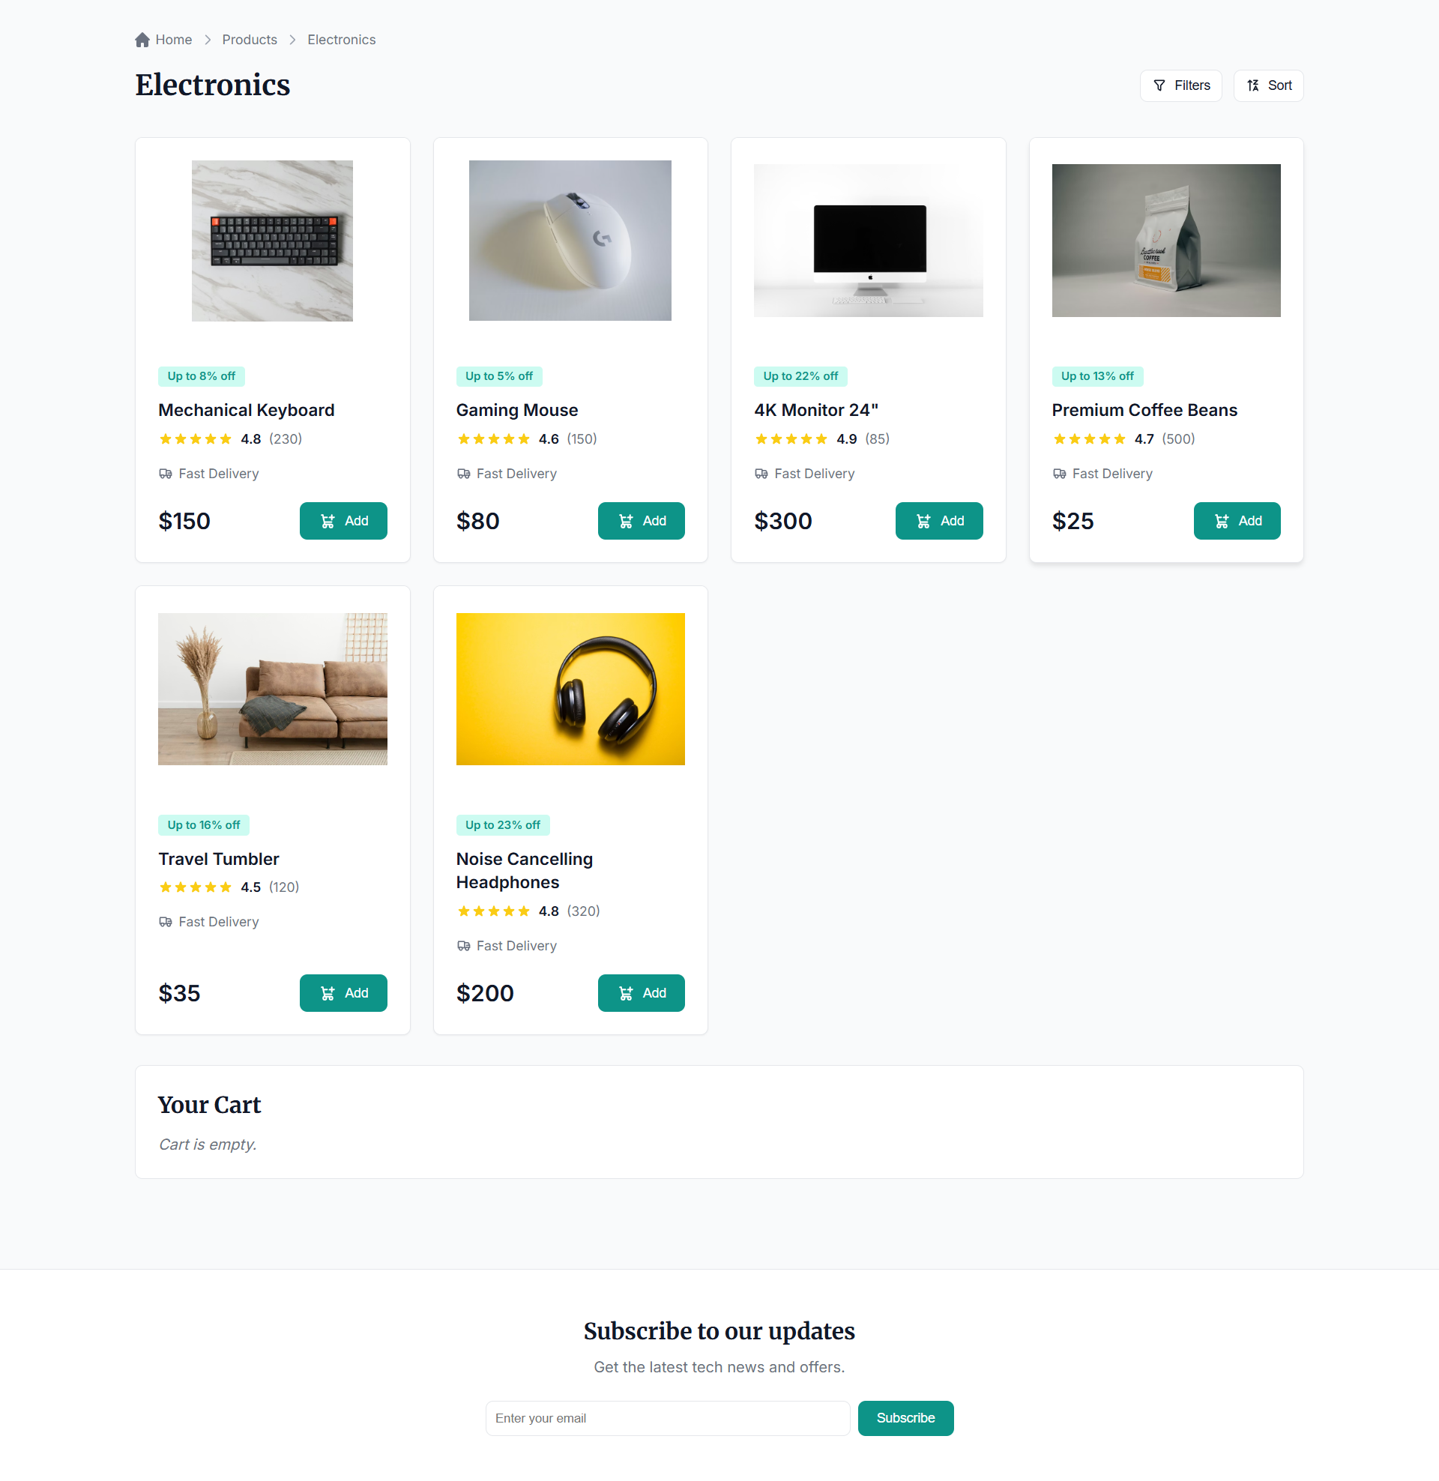

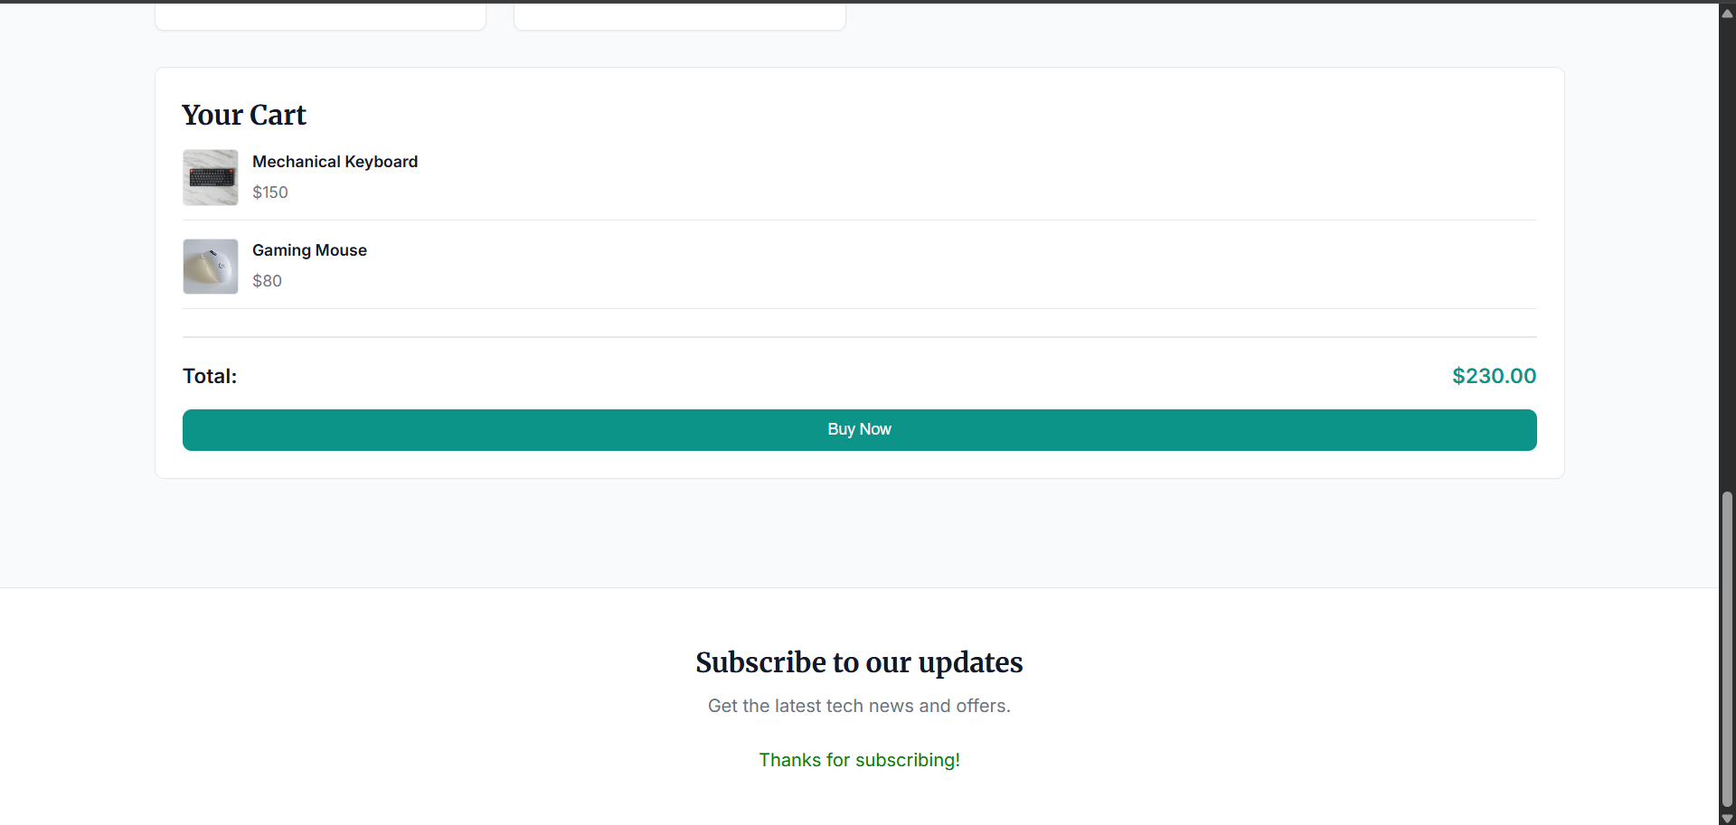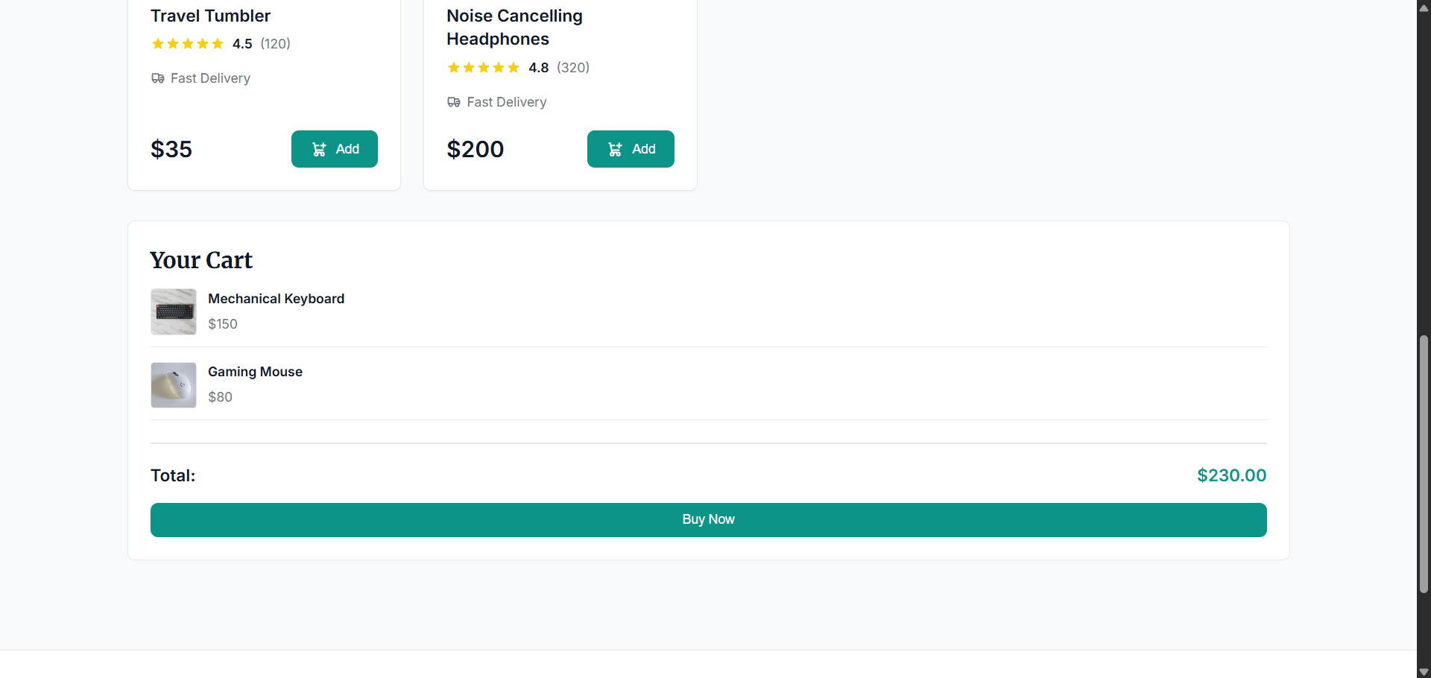

Analisis dan Pembahasan
- Struktur modular ES6+ memudahkan pemisahan tanggung jawab antar file.
- Komponen ProductList, Cart, dan Newsletter membuat UI lebih terorganisir.
- Store.js dipakai sebagai state management sederhana untuk products dan cart.
- Event-driven flow (click dan submit) membuat interaksi pengguna responsif.
- Penggunaan deepClone membantu menghindari mutasi state langsung saat membaca state.

Kesimpulan
Praktikum berhasil diimplementasikan. Aplikasi webstore sederhana dapat menampilkan data produk, mengelola keranjang belanja, melakukan checkout, dan menangani langganan newsletter. Konsep modular ES6+ terbukti efektif untuk membangun aplikasi JavaScript yang rapi dan mudah dikembangkan.

Lampiran
https://github.com/AriqAhmadNayaka/WebPro4904/tree/AndhikaYuridho-707012500059

